CMPUT 307

Quiz 3, Due Feb. 28, 2022 (60 mins., max 40 marks)

NAME: Mohammed Azad

Perform the principal component analysis (PCA) considering the following two-dimensional vector (representing n = 4 points in 2D): $$X= \left[\begin{matrix}4 & 1 & -1 & -2 \\ 3 & 2 & -2 & -5\end{matrix}\right]$$

1. [5] Calculate mean $\overline{X}$**: $\overline{X}$**  
     
     
   **= $\left[\begin{matrix}0.5 \\ -0.5\end{matrix}\right]$**
2. [5] Center points by computing $X-\overline{X}$ $$X-\overline{X}=\left[\begin{matrix}3.5 & 0.5 & -1.5 & -2.5 \\ 3.5 & 2.5 & -1.5 & -4.5\end{matrix}\right]$$
3. [5] Calculate the covariance matrix $A=\frac{\left(X-\overline{X}\right){\left(X-\overline{X}\right)}^{T}}{n}$  
     
     
     
   A = $\frac{1}{4}\left[\begin{matrix}3.5 & 0.5 & -1.5 & -2.5 \\ 3.5 & 2.5 & -1.5 & -4.5\end{matrix}\right]\left[\begin{matrix}3.5 & 3.5 \\ 0.5 & 2.5 \\ -1.5 & -1.5 \\ -2.5 & -4.5\end{matrix}\right]= \frac{1}{4}\left[\begin{matrix}21 & 27 \\ 27 & 41\end{matrix}\right]= \left[\begin{matrix}5.25 & 6.75 \\ 6.75 & 10.25\end{matrix}\right]$

1. [10] Find the eigenvalues $λ_{1}, λ_{2}$ solving $det\left(A-λI\right)=0$ $$\left(5.25-λ\right)*\left(10.25-λ\right)- {6.75}^{2}=0 \\ λ^{2}-15.5λ+8.25=0 \\ λ=(14.948, 0.552)$$

1. [10] Calculate the $1^{st}$ eigenvector and $2^{nd}$ eigenvector $$\left[\begin{matrix}5.25-14.948 & 6.75 \\ 6.75 & 10.25-14.948\end{matrix}\right]\left[\begin{matrix}a \\ b\end{matrix}\right]= \left[\begin{matrix}0 \\ 0\end{matrix}\right] \\ 6.75b-9.698a=6.75a-4.698b \\ 11.448b=16.448a$$

$$a=0.696b$$

a1 = 0.571

b1 = 0.821  
first eigen vector = $\left[\begin{matrix}0.571 \\ 0.821\end{matrix}\right]$

$$\left[\begin{matrix}5.25-0.552 & 6.75 \\ 6.75 & 10.25-0.552\end{matrix}\right]\left[\begin{matrix}a \\ b\end{matrix}\right]= \left[\begin{matrix}0 \\ 0\end{matrix}\right] \\ 6.75b+4.698a=6.75a+9.698b \\ -2.948b=2.052a$$

$$a=-1.437b$$

a2 = -0.821

b2 = 0.571  
second eigen vector = $\left[\begin{matrix}-0.821 \\ 0.571\end{matrix}\right]$

[5] Interpret the PCA of $X$ in the following graph (draw the 2 eigen vectors and the 4 points):  
  
  
 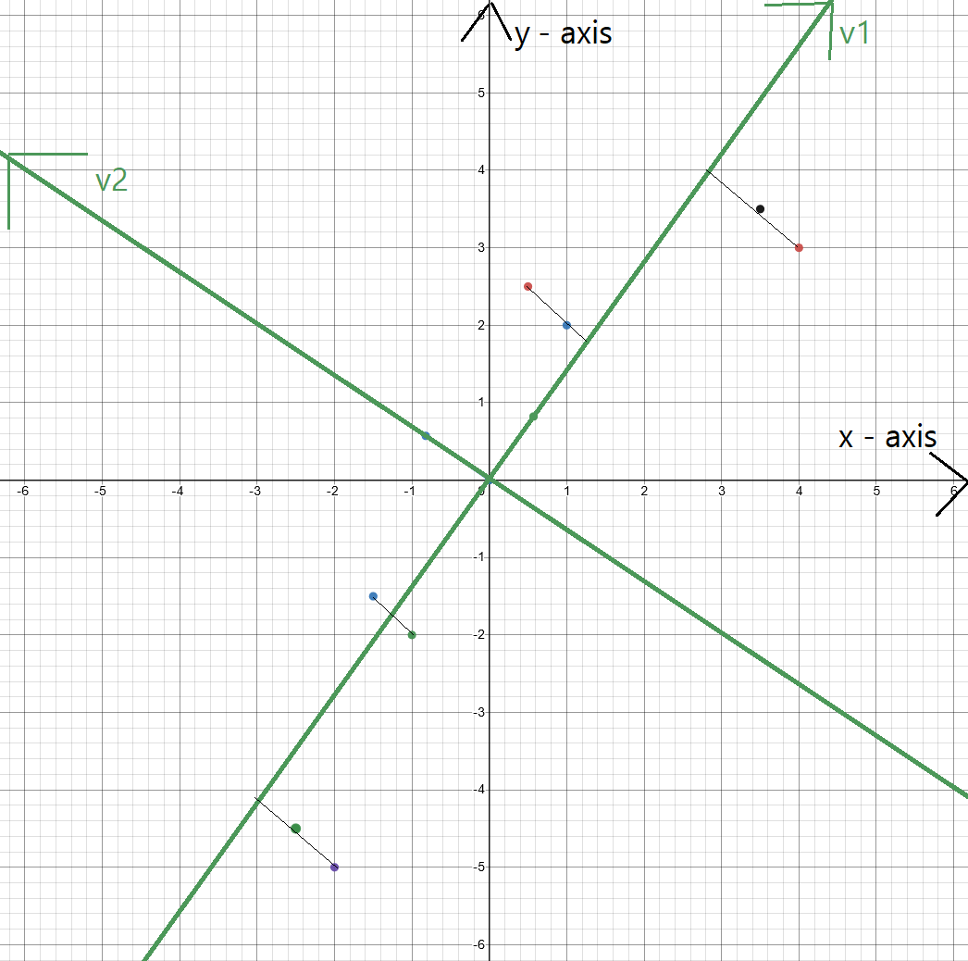The points along with centered points and the two eigen vectors